**PHP Comments, Include/Include_once, Require/Require_once**

**Why use Comments?**

* If you don’t work on the source code for some time, it’s easy to forget what the code does. Commenting the source code helps remember what the code does.
* Commenting source code is also very important when multiple developers have to work on the same project. The changes made by one developer can be easily understood by other developers by simply reading the comments.
* As the best practice, you must have 3 lines of comments for every 10 lines of code

**In this tutorial, you will learn-**

* [PHP Comments](https://www.guru99.com/comments-includeinclude-once-requirerequire-once.html#1)
* [PHP Include & PHP Include_once](https://www.guru99.com/comments-includeinclude-once-requirerequire-once.html#3)
* [Example : Include / Include_once](https://www.guru99.com/comments-includeinclude-once-requirerequire-once.html#4)
* [PHP Require & PHP require_once](https://www.guru99.com/comments-includeinclude-once-requirerequire-once.html#5)
* [Example : Require](https://www.guru99.com/comments-includeinclude-once-requirerequire-once.html#6)
* [PHP include vs require](https://www.guru99.com/comments-includeinclude-once-requirerequire-once.html#7)

**PHP Comments**

* Comments help us to understand the code
* Comments are explanations that we include in our source code. These comments are for human understanding.
* Single line comments start with double forward slashes // and they end in the same line.
* [PHP Include, Require & Comments](https://www.guru99.com/images/2013/04/php_single_comment.jpg)
* Multiple line comments start with a forward slash followed by the asterisk /* and end with the asterisk followed by the forward slash */.
* [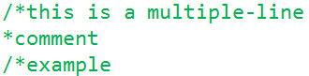](https://www.guru99.com/images/2013/04/php_multi_line_comments.jpg)

The diagram below shows a PHP file with both multiple line and single line comments PHP Example

[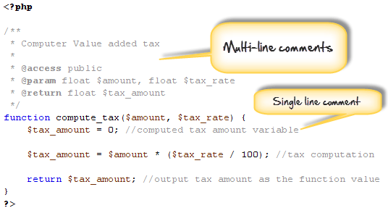](https://www.guru99.com/images/2013/04/php_comments.png)

**PHP Include & PHP Include_once**

The “include” php statement is used to include other files into a PHP file.

It has two variations, include and include_once.  Include_once is ignored by the PHP interpreter if the file to be included.

The include statement has the following syntax

<?php

include 'file_name';

?>

The include_once statement has the following syntax

<?php

include_once 'file_name';

?>

HERE,

* “Include/include_once” is the statement that includes file
* “'file_name'” is the name of the file to be included.

**Example : Include / Include_once**

Suppose you are developing a website that contains the same navigation menu across all the pages.

You can create a common header then include it in every page using the include statement Let’s see how this can be done.

* We will create 2 files names
* header.php, index.php

Below are the codes for; *header.php*

<a href="/index.php">Home</a>

<a href="/aboutus.php">About us</a>

<a href="/services.php">Services</a>

<a href="/contactus.php">Contact Us</a>

*index.php*

<?php

include 'header.php';

?>

The header page above will output

**PHP Require & PHP require_once**

The require statement has two variations, require and require_once.

The require/require_once statement is used to include file.

Require_once is ignored if the required file has already been added by any of the four include statements.

It has the following syntax

<?php

require 'file_name';

?>

<?php

require_once 'file_name';

?>

HERE,

* “require/require_once” is the statement that includes file
* “'file_name'” is the name of the file to be included.

**Example : Require**

Suppose we are developing a database powered application.

We can create a configuration file that we can include in all pages that connect to the database using the require statement. config.php

<?php

$config['host'] = 'localhost';

$config['db'] = 'my_database';

$config['uid'] = 'root';

$config['password'] = '';

?>

Let’s now look at the sample code that requires the config file. *Pages_model.php*

<?php

require 'config.php'; //require the config file

//other code for connecting to the database

?>

**Php include vs require**

The difference between include / require

|  |  |
| --- | --- |
| **Include** | **Require** |
| Issues a warning when an error occurs | Does not issue a warning |
| Execution of the script continues when an error occurs | Execution of the script stops when an error occurs. |

  Generally, it’s recommended using the include statement so that when an error occurs, execution of the script continues to display the webmaster email address or the contact us page.

The require statement should be used if the entire script cannot run without the requested file.

The “include” and “require” statements can be used at any line in the source codes where you want the code to appear.

**Summary**

* Single HTML code such as headers, footers, side bars etc. can be shared across many pages. This makes it easy to update the website by just updating a single file.
* PHP code such as database configuration settings, custom functions etc. can be shared across many pages ensuring the website/application uses the same settings.
* Comments are used to help understand source code. They are for human understanding
* Single line comment statements start with double forward slashes //.
* Multi-line comment statements are enclosed between /* statements */.
* The “include, include_once, require and require_once” statements are used to include files.
* Include_once/require_once is ignored if the requested file has already been included using any of the four statements.
* The “include” statement issues a warning and continues with the execution if the requested file has not been found.
* The require statement raises a fatal error and stops the script execution.
* The “include” statement should be in most cases except in situations where without the requested file to be include, the entire script cannot run.